# Study the connection between robustness and cellular aging

Kinnari Matheson, Orianne Morrison, Robin Levy

# Abstract

**Introduction:** Aging is an intricate process that encompasses the convoluted effects of numerous genes. Although decades of work has been dedicated to elucidating the mechanisms responsible for the complex behavior of aging, the effect of robustness has yet to be studied for its effect on aging. Therefore, in this study we consider the effects of robustness on lifespan using budding *Saccharomyces cerevisiae*, an effective model for study of aging. We **hypothesize** that cellular aging is influenced by the configuration of gene/ protein interaction networks for which robustness is a key factor in shaping the characteristics of the aging process. Connectivity, expression robustness, morphological plasticity, and growth fitness were used as proxies for robustness. In addition, we investigate the evolution patterns of genes in which mutations that are deleterious to lifespan are induced. **Methods:** The R- Statistical analysis tool was used to perform linear and multiple regressions on replicative lifespan, evolutionary distance, morphological plasticity, number of protein interactions, and fitness. **Results:**  The results of our study showed that replicative lifespan is positively correlated with both growth fitness and robustness and negatively correlated with morphological plasticity. In **conclusion,** significant relationships were established between robustness and replicative lifespan, suggesting that the ability to withstand stochastic variations in environment may significantly increase lifespan.

# Introduction

Although over a century of research by various scientists has been dedicated to determining the mechanisms behind aging, the complex nature of aging still remains to be elucidated. The process of aging is known to be influenced by the concomitant variables of genetics and environment. Thus, a number of hypotheses such as the cross-linking/ glycation hypothesis (Bailey , 2001) the oxidative - damage/ free radical hypothesis (Harman, 1992), and the genome maintenance hypothesis of aging (Rodiera, Kima, Campisia, Nijjara, & Yaswena, 2005)have arisen in effort to explain the multifactorial phenomenon of aging. However, aging is formally defined as the process of progressive deterioration of cellular functions due to protein modifications that cause a reduction in protein activity and specificity. Furthermore, research has found that cellular aging is  contingent on the modification of specific proteins and that various pathways are associated with longevity. More specifically, replicative life span is increased by  the deletion of genes  such as URE2, TOR1, SCH9 of the TOR signaling pathway  ( Dhami et al.). Nevertheless, researchers have proposed that despite the ability of specific proteins to influence longevity, it is believed that there are no 'aging' genes, but rather aging is an emergent property  of intricate gene networks.

Cells have internal networks, gene networks, which allow for the communication of the molecules inside of the cell. These gene networks consist of a collection of DNA segments that interact with one another, specifically receptor proteins, inhibition factors, transcription factors, and many more. Without these gene network expressions it would be very difficult for the cells to function and eventually survive. Depending on the cell and environment it is in there may be more or less expression of some genes, which will allow the cell to adapt and survive. Through studies of evolutionary and computational data, it is evident that gene networks have a major ability to adapt by creating the genes necessary ( Nehaniv, 2005). The expression of each gene must be at equivalent levels and punctual in order to maintain the homeostasis of the cell. The ability of a cell to evolve for survival depicts the robustness of the cell (Macneil and Walhout, 2011). The understanding of the complex connections of gene networks can be helpful when determining the robustness of a cell in terms of noise (Ciliberti et al., 2007). Studies show that gene networks have the ability to evolve to become more or less robust, making robustness an evolvable trait (Ciliberti et al., 2007).

Robustness is defined as the ability to withstand mutational, environmental, or probabilistic variation. It is possible that mechanisms of robustness may have developed to protect cells from harmful mutations or environments. Waddington first observed the correlation between the experimental perturbation and robustness of a network (Masel and Siegal 2009). An organism that can adapt to environmental stimulus and noise may have a longer lifespan. Therefore, robustness as a characteristics of the gene network may correlate with cellular aging, another emergent property. Fitness, evolutionary distance, morphological plasticity, protein interactions are factors in the definition of the robustness of a network. Linear regressions have revealed significant relationships between these correlates of robustness and replicative lifespan.

Aging can be seen as a process of progressive deterioration of cellular functions due to protein modifications that cause a reduction in protein activity and specificity (citation?). Cellular function deterioration increases as the defense mechanisms of the cell declines which leads to the lack of productivity in all protein activities.  As the depletion of functionality of these proteins increases, the cell’s network will be less able to compete against surrounding changes. In other words the cells network robustness decreases.

Materials and Methods

The data for this experiment was obtained from literature articles. The “2011 Comparative analysis of gene expression and regulation of replicative aging associated genes in *S. cerevisiae” and “*Genomic expression programs in the response of yeast cells to environmental changes” articleand the Saccharomyces Cerevisiae Morphological Database provided the actually yeast data used in this study. The “Self-replication, evolvability and asynchronicity in stochastic worlds. In Stochastic Algorithms: Foundations and Applications” article and “The Genetic Landscape of a Cell” article provided the procedural aspects of how to interpret the data in a computational manner. For background information of the study the “Gene regulatory networks and the role of robustness and stochasticity in the control of gene expression” article was referenced.  
  
Results  
  
*Fitness vs. Lifespan Regression Analysis*  
  
Fitness versus lifespan regression analysis was performed to determine which factors have the greatest influence on replicative lifespan. Comparisons between the various variables and lifespan were performed and a scatter plot was generated using the data from the medium having the highest R-value and the lowest p-value. Based on the results of the analysis, the YPE condition had the greatest effect on replicative life span.

*Evolutionary Distance vs. Lifespan Regression Analysis*  
  
Evolutionary distance (Ka) was incorporated into a column in the replicative lifespan table. The evolutionary distances between genes in *S. cerevisiae* and homologs in *S. paradoxus* and *S. bayanus* were used as predictors of robustness in these analyses. A linear regression was performed and plotted to determine the correlation of evolutionary distance and lifespan. The degree of protein interactions was calculated with the creation of a vector of the open reading frames in the protein interaction pairs data followed by a summary of the relationships in a data frame.   
  
*Protein and Genetic Interactions vs. Lifespan Regression Analysis*  
  
A similar mechanism of concatenation was utilized to combine protein interaction data and lifespan. The frequency of protein interactions was summarized from the list of protein pairs that associate. Then, lifespan was matched with the frequency data to perform a linear regression between the amount of protein interactions and the replicative lifespan. Plot regression analysis was also carried out.   
  
  
*Morphological Plasticity vs. Lifespan Regression Analysis*  
  
Morphology plasticity was analyzed due to its inverse relationship with robustness. Standard deviation values of the deletion mutants and lifespan data were compared. The linear regression of replicative life span and the standard deviation was summarized to show possible correlations between replicative life span and morphological plasticity. The results were plotted and a line of association was shown to represent the correlation between replicative lifespan and morphological plasticity. A multiple regression analysis was done to see the correlation between lifespan, morphological plasticity and fitness (Table 3).  
  
The linear regression between replicative life span and morphological plasticity showed a weak, but still a significant correlation (R2 = 0.03431, p-value = 1.349e-05). The multiple linear regression of replicative life span as compared to evolutionary distance, fitness, degree of protein reactions, and morphological plasticity showed no significant relationship. Fitness was tested for its association with degree of protein interactions, evolutionary distance, and morphological plasticity, a significant relationship was demonstrated between these variables and the fitness of the samples (R2 = 0.3525, p-value= 2.318e-07). The correlations between fitness, replicative life span, and morphological plasticity robustness all yielded R2 below 0.5 illustrating weak correlations between these variables. However, there was still a significant relationship between these variables (Table 3).

# Discussion

The growth fitness ethanol medium has the most significant correlation with lifespan, suggesting that respiratory metabolism is most informative to lifespan.

There is a significant negative correlation between replicative life span and morphological plasticity, which serves as a proxy of robustness. According to the multiple regressions of morphological plasticity and replicative life span, it is evident that there is a negative correlation between the two. The multiple regression between fitness and the other factors of robustness was used to see the effects that the factors of robustness have on fitness, which is also a factor of robustness.

# Conclusion

Significant relationships were established between robustness and replicative lifespan which confirms our hypothesis. Robustness positively correlates with replicative lifespan, suggesting that the robustness increases replicative lifespan. In this experiment morphological plasticity is statistically shown to be negatively correlated to replicative life span. It is therefore proven to be inversely related to robustness.

# References

1. Bailey , A. J. (2001, May). Molecular Mechanisms of Aging In Conncective Tissues. *Mechanism of Ageing and Development* , 735-755.
2. Harman, D. (1992). Free Radical Theory of Aging. *Mutation Research/DNAging* , 257-266.
3. Rodiera, F., Kima, S.-H., Campisia, J., Nijjara, T., & Yaswena, P. (2005). Cancer and aging: the importance of telomeres in genome maintenance. *International Journal of Biochemistry and Cell Biology* , 970-990.
4. Fraser,H. G.,A. E. Hirsh, L. M. Steinmetz, C. Scharfe and M. W. Feldman, 2002 Evolutionary Rate in the Protein Interaction Network. Science **296:** 750-752.
5. Han J. J.,N. Bertin,T. Hao,D. Goldberg, G. F. Berriz,L. V. Zhang,D. Dupuy,A. J. M. Walhout,M. E. Cusick,F. P. Roth and M. Vidal, 2004 Evidence for dynamically organized modularity in the yeast protein–protein interaction network. Nature **430:** 88-93.
6. Dhami, S. P. S.,N. Mittal, S. C. Janga,  and R. Nilanjan, 2011 Comparative analysis of gene expression and regulation of replicative aging associated genes in *S. cerevisiae.* Molecular  BioSystems **7:** 403–410.
7. Wagner, A., 2000 Robustness against mutations in genetic networks of yeast. Nat Genet. **24**: 355-61.
8. Cooper,T. F., A. P. Morby, A. Gunn, and D. Schneider, 2006 Effect of random and hub gene disruptions on environmental and mutational robustness in *Escherichia coli.* BMC Genomics, **7**: 237.
9. Jingjing, Li, Zineng Yuan, Zhaolei Zhang, 2010 The Cellular Robustness by Genetic Redundancy in Budding Yeast. Plos Genetic **6**: 1-10.
10. Nehaniv, C L. Self-replication, evolvability and asynchronicity in stochastic worlds. In Stochastic Algorithms: Foundations and Applications, volume 3777 of Lecture Notes in Computer Science, pages 126–169. Springer, 2005.  
     Aldana M, Balleza E, Kauffman S, Resendiz O. Robustness and evolvability in genetic regulatory networks. *J Theor Biol.* 2007;245:433–448.
11. Ciliberti S, Martin OC, Wagner A. Robustness can evolve gradually in complex regulatory gene networks with varying topology. *PLoS Comput Biol.* 2007b;3:e15.
12. Macneil LT, Walhout AJ. Gene regulatory networks and the role of robustness and stochasticity in the control of gene expression. *Genome Res.* 2011;**21**:645–657.

# Figures and Tables

**Table 1.** This table illustrates the results of the fitness versus lifespan regression analysis. YPE had the most significant relationship with replicative lifespan.

|  |  |  |  |  |
| --- | --- | --- | --- | --- |
| **Comparison** | **Medium** | **Multiple R2** | **p-value** | **Std. Dev.** |
| RLS | YPD | 0.02545 | 0.01499 | 10.240 |
| RLS | YPDGE | 0.02824 | 0.01034 | 12.393 |
| RLS | YPG | 0.03613 | 0.00366 | 10.145 |
| RLS | YPE | 0.0632 | 0.00011 | 12.246 |
| RLS | YPL | 0.03474 | 0.00439 | 11.620 |

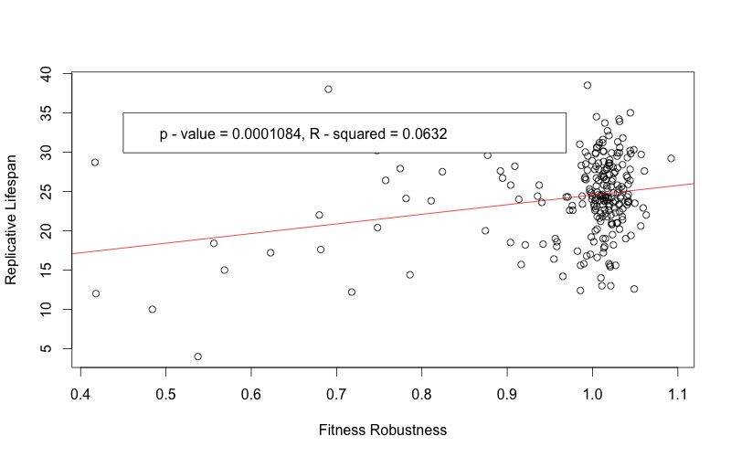

**Figure 1.** Linear regression of the significant positive correlation between replicative lifespan and growth rates in ethanol medium. Ethanol is the most informative medium among the various conditions including lactose, glucose and dextrose.

|  |  |  |  |
| --- | --- | --- | --- |
| **Species 1** | **Species 2** | **Multiple R2** | **p - value** |
| *S. cerevisiae* | *S. paradoxus* | 0.002773 | 0.3758 |
| *S. cerevisiae* | *S. bayanus* | 0.3482 | 0.386 |

**Table 2.** The relationship between replicative lifespan and evolutionary distance. The regressions show no correlation (R2 = 0.002773, p-value = 0.3758) between replicative lifespan and evolutionary distance within the *Saccharomyces* genus.  Also, a similar relationship was observed between lifespan and protein interactions (R2 = 0.3482, p-value = 0.386).

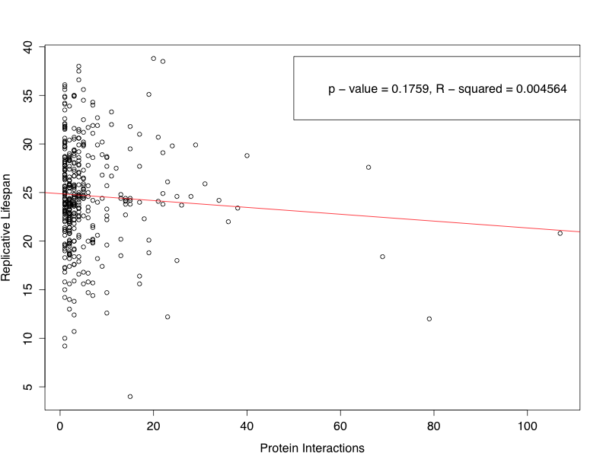

**Figure 2.** Scatterplot of the negative correlation between the frequency of protein interactions and the replicative lifespan in *Saccharromyces cerevisiae*.

**Table 3.** Morphological plasticity. Linear and multiple regression results for morphological plasticity and other correlates of robustness.

|  |  |  |  |
| --- | --- | --- | --- |
| Factors in Multiple Regression | | R2 value | p-value |
| RLS | * **Morphological Plasticity** | **0.03431** | **1.349 x 10-5** |
| RLS | * **Evolutionary Distance** * **Fitness** * **Number of Protein Interactions** * **Morphological Plasticity** | **0.06907** | **0.2389** |
| Fitness | * **Number of Protein Interactions** * **Morphological Plasticity** * **Evolutionary Distance** | **0.3525** | **2.318 x 10-7** |

Morphological Plasticity

Lifespan

Robustness

Growth Fitness

**Figure 3.** A schematic overview of significant relationships of robustness and cellular aging. Positive and negative correlations are shown.